

**Program Name: Masters of Computer Applications**

**Academic Year: 2021-2022 Winter Semester**

**Year: FYMCA , Sem-II**

**Subject Code: MCA 203**

**Big Data Analysis**

**Course Instructor: Yudhishthir Raut**

**Lab Instructor: Madhuri Pagale**

Submitted by: PRN:

Bharti Hotchandani 20210804021

Honey Denbani 20210804025

Ujwal Patil 20210804033

Pratik Ugale 20210804043

**Department of computer science and engineering**

**D. Y. Patil International University, Akurdi**

**INDEX**

1. **Abstract**
2. **Introduction**
3. **project objective**
4. **Project Definition**
5. **Project Specifications**
6. **Product Architecture and Components**
7. **Functional Diagram**
8. **User Interface Image**
9. **Applications**
10. **Project background**
11. **Comparative Study**
12. **System Design**
13. **System Testing and Analysis**
14. **Overall Results, Analysis and Discussion**
15. **Limitation and Challenges**
16. **Project Analysis**
17. **Future Work**
18. **18. References**

#### **Abstract**

Face detection and face recognition are very important technologies these days, furthermore we noticed that they got have a variety of uses such as cellphones, army uses, and some high risk information offices. We decided to make a device that detects and recognize the face as a student attendance system and can be a substitute for the regular paper attendance system and finger print attendance system. The main function in our project is going to be done using openCV and pandas.. Our project is based on a main program in OpenCV library that detects and recognize faces with giving scores and parameters, furthermore the subsystems are an Excel sheet that is integrated with the program. Components of our project are OpenCV, Pandas, Tkinter program as the main system and subsystems, Office Excel sheet to include students names, and a computer (or laptop) to integrate the programs together.

# **Introduction**

# 

# **Project Definition**

Design of an automatic class attendance system using face detection. The system requires a video capture device, OpenCV, Tkinter, PIL, Pillow to be implemented successfully. It detects the faces and mark attendance accordingly. This system will prevent unnecessary wastage of time of classes that is usually wasted in form of class roll calls and proxy.

## **Project Objectives**

1. Reducing time wastage during conventional class attendance.
2. Utilizing latest trends in machine vision to implement a feasible solution for class attendance system.
3. Automating the whole process so that we have digital environment.
4. Preventing fake roll calls as one to one attendance marking is possible only.
5. Encouraging the use of technology in daily lives.

**Project Background**

In the face detection and recognition system, the process flow is initiated by being able to detect the facial features from a camera or a picture store in a memory. The algorithm processes the image captured and identifies the number of faces in the image by analyzing from the learned pattern and compare them to filter out the rest. This image processing uses multiple algorithm that takes facial features and compare them with known database.

The motivation behind this project is to simplify the means by which attendance is taken during lectures and how much time it takes. The use of ID cards or manually calling out attendance and writing it down on sheets is not productive and efficient. This system will detect the number of faces on the class and will also identify them from the store database. With the face detection and recognition system in place, it will be easy to tell if a student is actually present in the classroom or not.

## 

### **1.4.1 User Interface Image**

## Applications

## **2.1**

**Functional dig.**

1. **System Testing and Analysis**
2. **System Testing and Analysis**
3. **System Testing and Analysis**

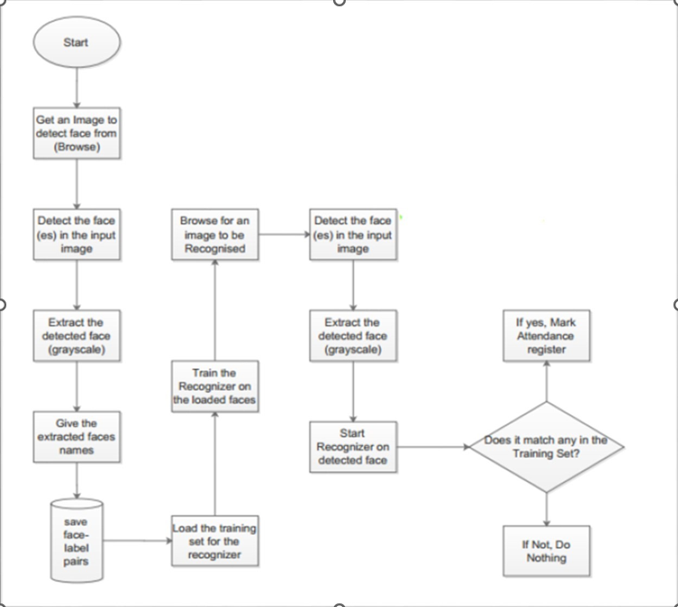**System Testing and Analysis.**

**Overall Result**

##### **Limitation and Challenges**

##### **Conclusions**

Number of modules are available on OpenCV to achieve incredible number of tasks freedom to The Automatic Class Attendance System implemented in this project would be much more difficult if it was not implemented on OpenCV . The objective of class attendance system is to automate the time consuming and error prone attendance system.

There are always limitations of every system. One can only have fixed number of students and provide less freedom to have interclass attendance system. This means the attendance system for one class can’t be used for attendance system of other class. One must change programming to do this.

The Project experience was tremendous as we learned the core of vision algorithms and different programming techniques of OpenCV . We learned how can a problem be simplified into smaller tasks and can be achieved successfully.

##### 

##### **Future Work**

1. Scaling the number of attendees (which can be done easily by any user).
2. Optimizing the synchronization between OpenCV , Tkinker Pandas and Excel attendance sheet.

Our project can be implemented in a computer and then the user take pictures (or upload them) to the vision assistant and add their names of the desired students in excel sheet.

##### 

**Future Recommendations**

The system can be made more flexible and scalable using these recommendations. Please note that the system implemented here is just a prototype of idea presented via this project. The recommendations are as follows:

* The system can be extended to more number of students with freedom to change list of students according to class changes.

The system can be made more flexible to allow updating of templates in case student incurs

significant amount of change in his facial features

* The system can also be extended to allow better face recognition algorithm in which even rotational features of face can be detected efficiently.